1. Project #1: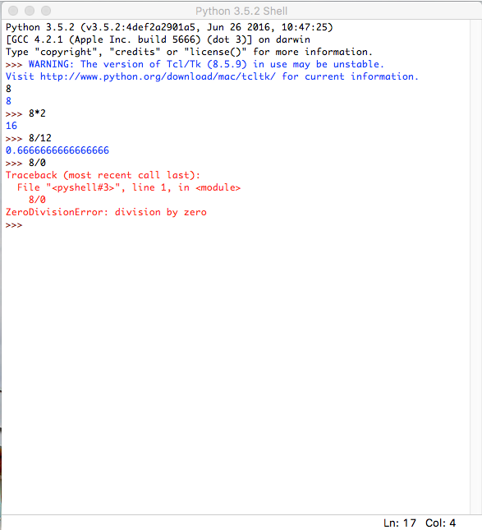
2. Project #2: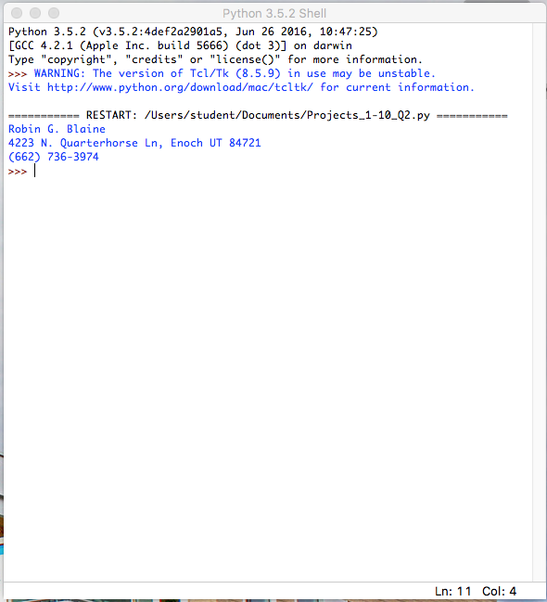
3. Project #3: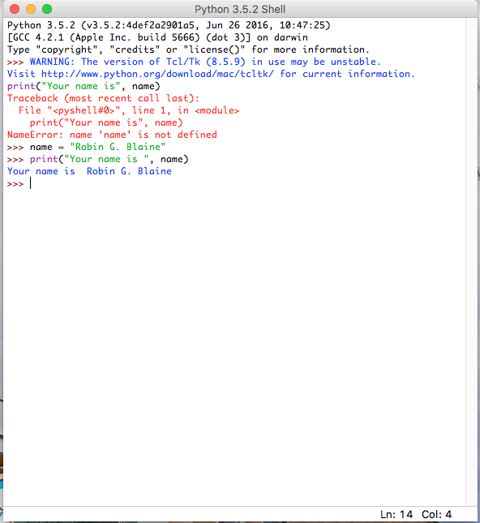
4. Project #4: The program as shown in the exercise gave a syntax error…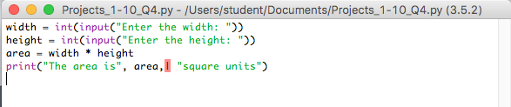After removing the pipe from the program, I got these results…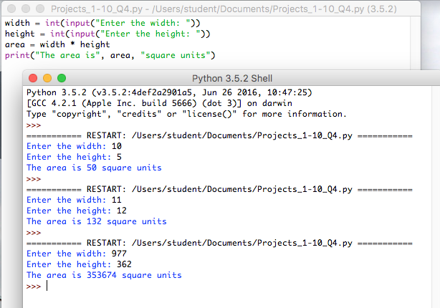
5. Project #5: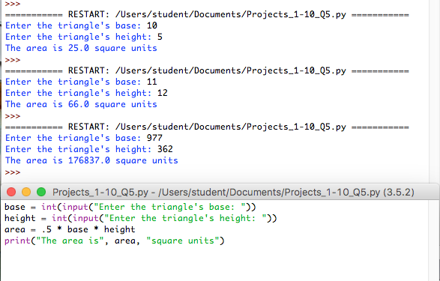
6. Project #6: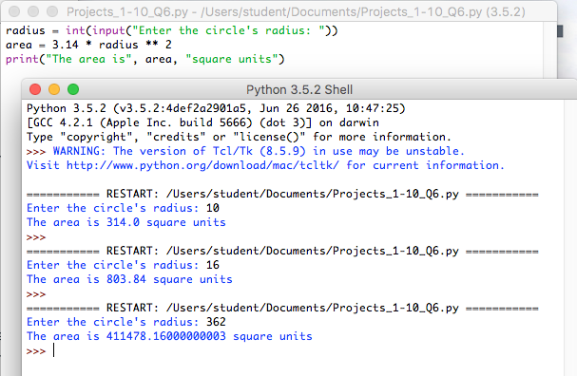
7. Project #7: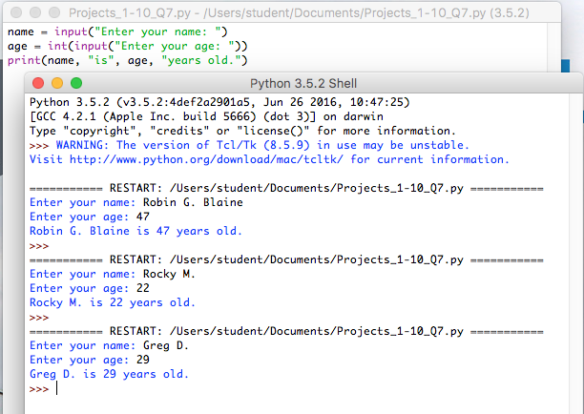
8. Project #8: The *raw_input* function was renamed to *input* in Python 3. A naked input statement inputs the variable as a string and cannot be added directly to an integer.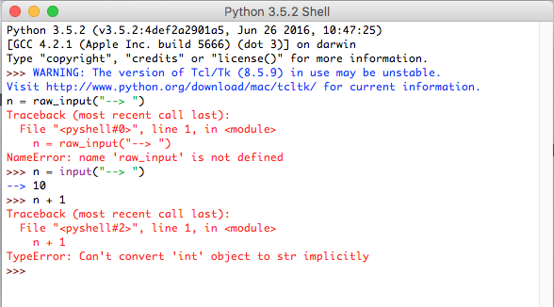
9. Project #9: my input was stored as a string in the variable *name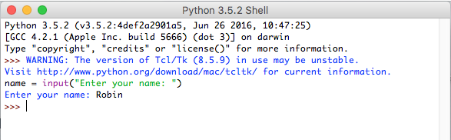*
10. Project #10: 